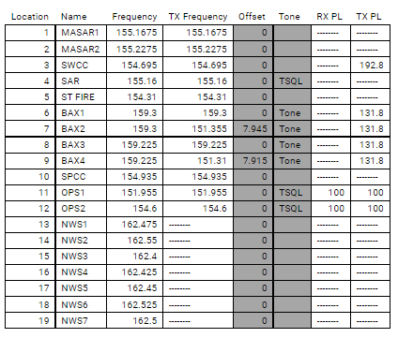

S: Scan on off

A :Scan add delete

B & C Not Assigned

5 watt